2024-2025 Term 2 Examination  Computer Literacy  Form 3  Carmel Holy Word Secondary School  2024 – 2025 Term 2 Examination  Secondary 3 Computer Literacy  Question Book  Date : 13th June 2025  Time : 10:40 a.m. – 11:10 a.m.  Time Limit : 30 minutes  No. of Pages : 7  Total mark : 40  Instructions:  - You should write your name, class, class number and the examination venue in the spaces provided on Page 1 after the examination start announcement is made.  - There are three sections, A, B and C, in this Paper.  - ANSWER ALL QUESTIONS. Answers to Section A, B and C should be written in the answer sheet provided. | Name  Class  Class No.  Venue  By Markers  Total / 40
Section A: Multiple Choice Questions (15 marks)
Choose the most suitable answers.

1. What is the output of the following program?
print("I Love \"Jesus\"")
A. I Love \"Jesus\"
B. I Love "Jesus"
C. I Love 'Jesus'
D. This program cannot be compiled.

2. Which of the following codes can be compiled successfully?
A. 1Love = Jesus
B. 2Square = 4
C. _3_3 = 9
D. import = "3E"

3. What is the output of the following program?
i = "3"
j = int(i + i)
print(str(j) + str(j))

A. 3333
B. 66
C. 12
D. 9

4. Read the following program.

L = input()
R = input()
print(R + " in the " + L + " always!")
Input the following text in the program in order:
Lord
Rejoice
What is the output of the program in the terminal?
A. R in the L always!
B. Rejoice in the Lord always!
C. Lord in the Rejoice always!
D. R + in the + L + always!

5. Read the following program.

k = int(input())
print(str(k + k) + str(k * k))
Input the following text in the program:
2
What is the output of the program in the terminal?
A. 224
B. 44
C. 2222
D. 8
6. Which of the following codes print text Y2025 in the terminal?
A. X = "Y"
print(X + str(20 + 25))
B. X = 20
print("Y" + str(X * 101) + 5)
C. X = "20"
print("Y" + X + str(int(X) + 5))
D. X = "2025"
print("Y" + int(X))

7. Read the following program.

A = input()
B = A + input()
C = B + input()
print(A + B + C)
Input the following text in the program in order:
C
H
W
What is the output of the program in the terminal?
A. CHWCHW
B. CCHHWW
C. CCHCHW
D. CCCHHW

8. Read the following program.

A = int(input())
B = int(input())
print(A % 4 + B)
Input the following text in the program in order:
34
33
What is the output of the program in the terminal?
A. 32
B. 33
C. 34
D. 35

9. What is the output of the following program?
x = 101
if x >= 100:
x = x - 1
elif x <= 100:
x = x - 2
print(x)

A. 97
B. 98
C. 99
D. 100

10. What is the output of the following program?
x = 4
while x <= 100:
x = x + x
print(x)

A. 64
B. 128
C. 104
D. This program cannot be compiled

11. What does the following code output?

import random
print(random.randint(1, 3))

A. Always prints 1
B. Always prints 3
C. Prints a random integer: 1, 2, or 3
D. Error because randint() cannot be used

12. What library does the following code require to work?

cv2.imshow("Frame", frame)

A. gTTS
B. OpenCV
C. GoogleCloudTranslate
D. SpeechRecognition

13. What is the purpose of cv2.waitKey(0) in a video loop?

A. Waits for a key press
B. Displays audio input
C. Converts speech to text
D. Saves an image

14. Which statement about gTTS is not correct?
A. It converts text to mp3 audio
B. It needs internet access
C. It requires playsound to play audio
D. It can translate text into Chinese

15. Which of the following lines records the user’s voice using the speech_recognition module?
A. text = recognizer.recognize_google(audio)
B. tts = gTTS("Hello")
C. cv2.imread("image.jpg")
D. result = translator.translate("Hello", dest="zh-tw")

Section B: Short Questions (15 marks)
All answers should be written in the spaces provided in the answer sheet.

1. Fill in the blanks to complete the text-to-speech program. (5 marks)

gtts gTTS love.mp3 save playsound input

from ____(i)_____ import gTTS
from ____(ii)______ import playsound
tts = ____(iii)____("Jesus loves you", lang="en")
tts.___(iv)_____("love.mp3")
playsound("____(v)____")

2. Fill in the blanks to translate the English sentence “God loves you” into Chinese. (5 marks)

en input Client zh translate result

from google.cloud import translate_v2 as ____(i)_____
import os
os.environ["GOOGLE_APPLICATION_CREDENTIALS"] = "password.json"
client = translate. ____(ii)_____ ()
result = client.translate("God loves you", source_language="____(iii)_____", target_language="____(iv)_____")
print(____(v)_____["translatedText"])

3. Fill in the blanks to complete the speech recognition program. (5 marks)

source recognizer sr text translate audio

import speech_recognition as ____(i)_____
recognizer = sr.Recognizer()
with sr.Microphone() as source:
audio = ____(ii)_____.listen(____(iii)_____)
text = recognizer.recognize_google(____(iv)_____, language="en")
print(____(v)_____)

Section C: Long Question (10 marks)
1. A student wants to write a Python program using OpenCV to load a video and detect faces with a pre-trained Haar Cascade model.
Below is the incomplete code:
Line | Program
1  2  3  4  5  6  7  8  9  10  11  12  13  14  15  16  17  18  19  20  21  22 | import cv2  # Load the Haar Cascade face detection model  face_cascade = cv2.CascadeClassifier("haarcascade_frontalface.xml")  # Load video  video = cv2.VideoCapture('WalkingGirl.mp4')  while True:  ret, frame = video.read()  if not ret:  break  gray = cv2.cvtColor(frame, cv2.COLOR_BGR2GRAY)  faces = face_cascade.detectMultiScale(gray, 1.1, 4)  for (x, y, w, h) in faces:  cv2.rectangle(frame, (x, y), (x+w, y+h), (255, 0, 0), 2)  cv2.imshow("Face Detection", frame)  cv2.waitKey(1)

(a) Which two files are required for running this program. (2 marks)

(b) Describe the purpose of line 12 and 13. (2 marks)

(c) What is the meaning of x, y, w and h in line 18 and 19? (4 marks)

(d) The student observed that some detected objects in certain frames are not actual faces.

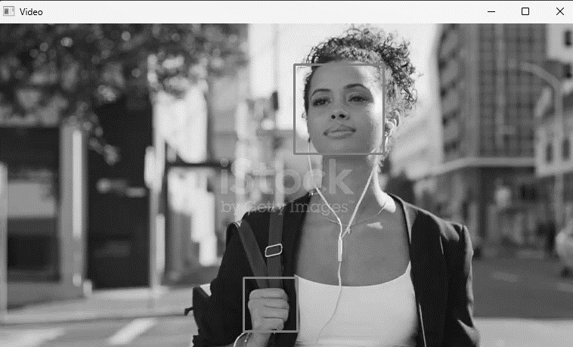
Face detected correctly
Incorrectly detected

(i) Give a reason for this problem. (1 mark)

(ii) Which line of code should be modified to fix this issue? (1 mark)

End of Paper

Carmel Holy Word Secondary School
/40
2nd Term Examination 2024 - 2025
Secondary 3 Computer Literacy
Answer Sheet
Name : Time allowed : 30 minutes

Section A: Multiple Choice Questions (15 marks)
Choose the most suitable answers. Use an HB pencil to blacken the circle next to the question numbers below.
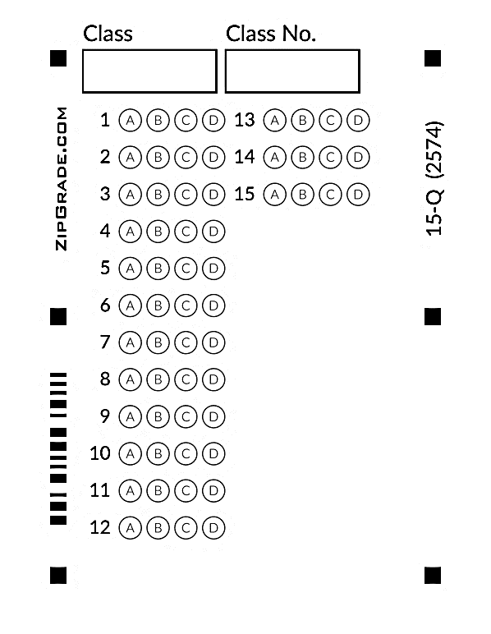
Section B: Short Questions (15 marks)
All answers should be written in the spaces provided.

1. | (i) | (ii) | (iii)
 | (iv) | (v)

2. | (i) | (ii) | (iii)
 | (iv) | (v)

3. | (i) | (ii) | (iii)
 | (iv) | (v)

Section C: Long Question (10 marks)

1. (a) File 1:
File 2:
(b)

(c) x: ____________________ of detected faces.
y: ____________________ of detected faces.
w: ____________________ of detected faces.
h: ____________________ of detected faces.
(d) (i)

(ii) Line:
End of Paper

2024-2025 Term 2 S3 CMP Examination
Suggested Answer
Section A: @ 1mark
BCABB CCDDB CBADA

Section B:

1. | (i) gtts | (ii) playsound | (iii) gTTS
 | (iv) save | (v) love.mp3

2. | (i) translate | (ii) Client | (iii) en
 | (iv) zh | (v) result

3. | (i) sr | (ii) recognizer | (iii) source
 | (iv) audio | (v) text

Section C:

1. (a) File 1: haarcascade_frontalface.xml
File 2: WalkingGirl.mp4
(b) It quits the loop if no more frames are available.
(c) x: x-coordinate of detected faces.
y: y-coordinate of detected faces.
w: width of detected faces.
h: height of detected faces.
(d) (i) This happens because the program wrongly sees non-faces as faces.
(ii) Line: 16

